Nama : Leony Novelia Hutahaean

NIM : 12030123130169

Kelas : Akuntansi-C

Kasus : Case point 5.3: Rock Solid Outfitters (Part 2)

1. DFD
2. DFD Level 0

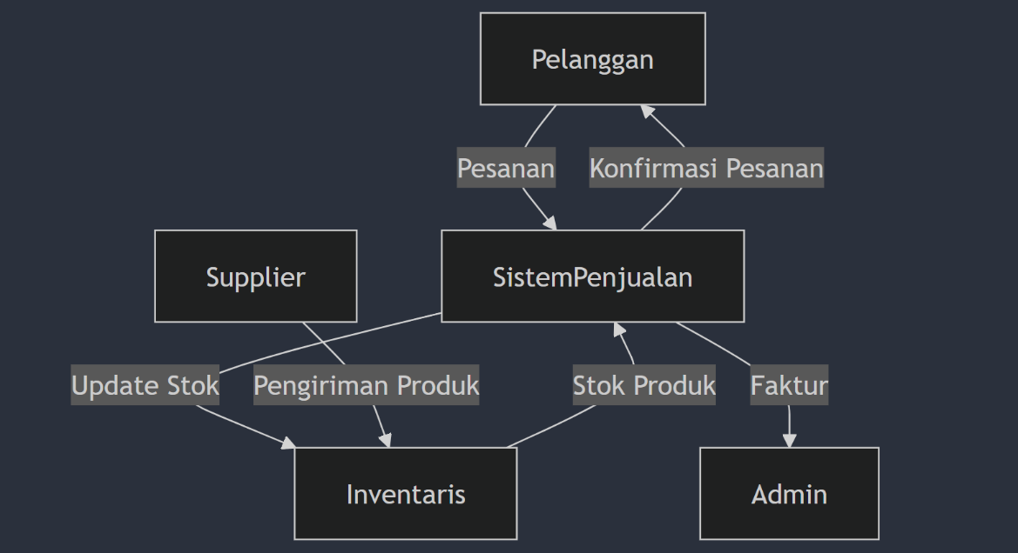(Mermaid)

(Draw.io)

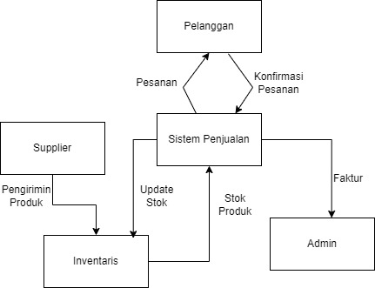

1. DFD Level 1

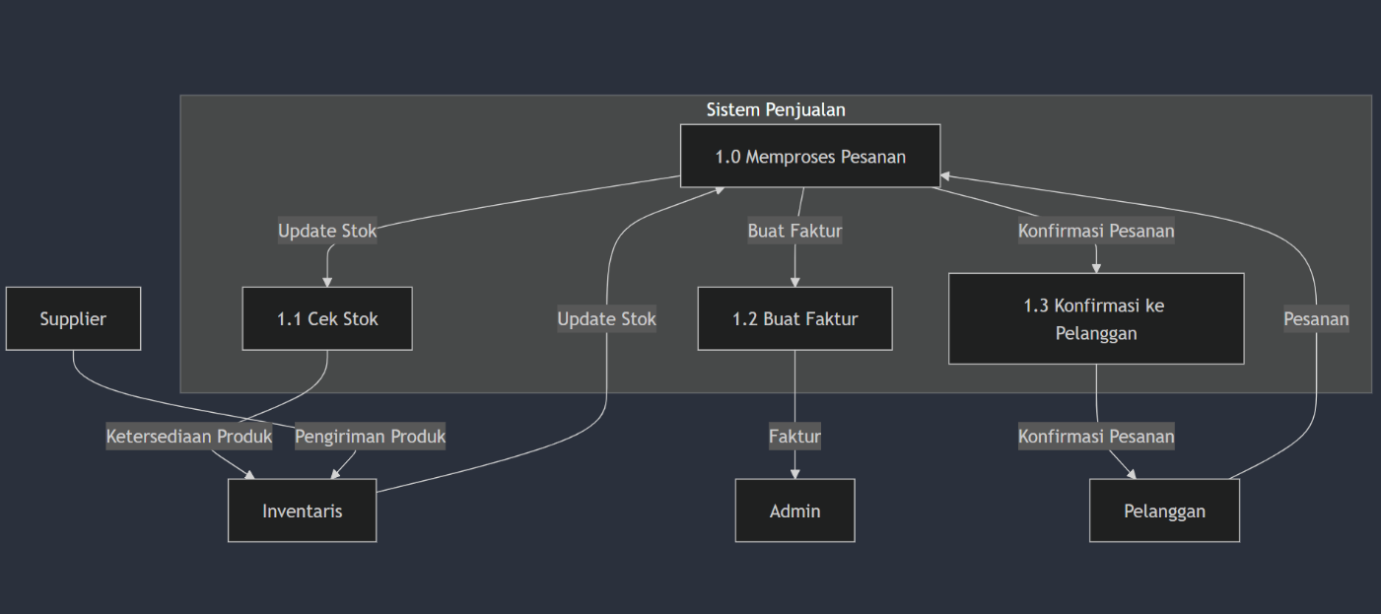(Mermaid)

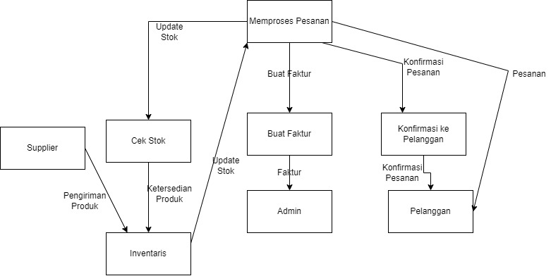(Draw.io)

1. Entity Relationship Diagram (ERD)

(Mermaid)

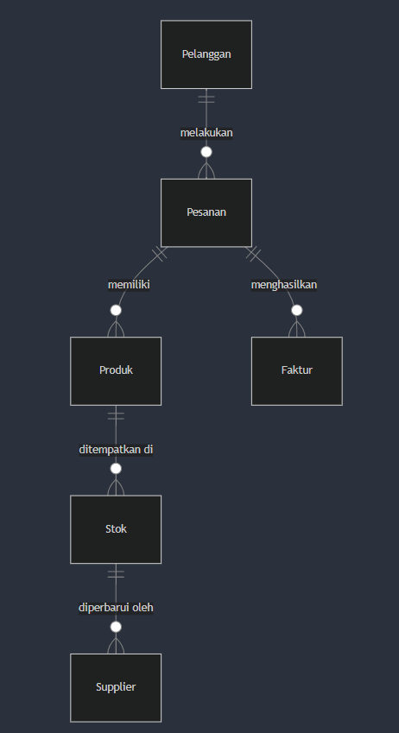

(Draw.io)

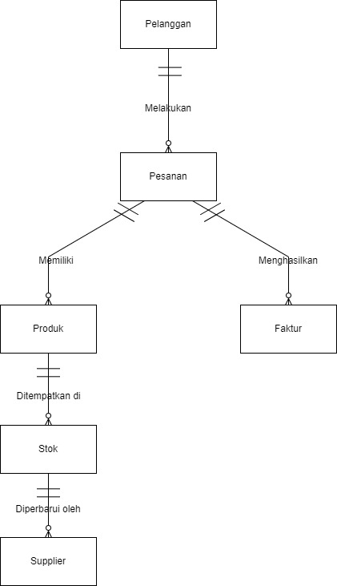

1. UML Diagram
2. Class Diagram

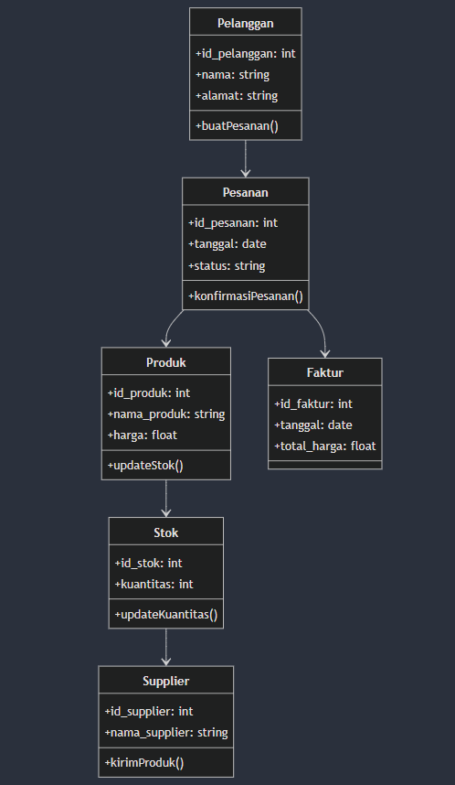(Mermaid)

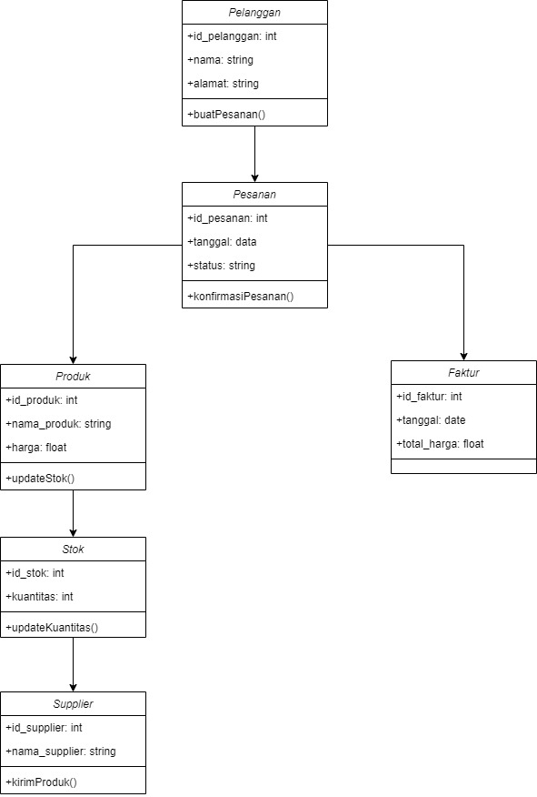(Draw.io)

1. Sequence Diagram

(Mermaid)

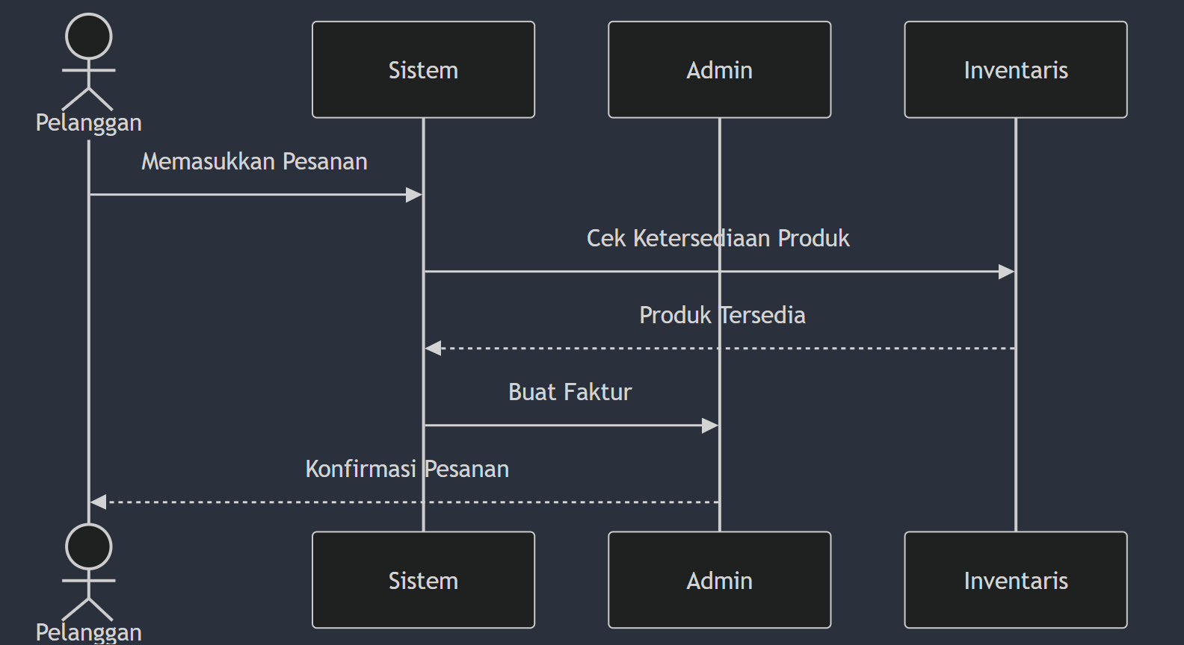

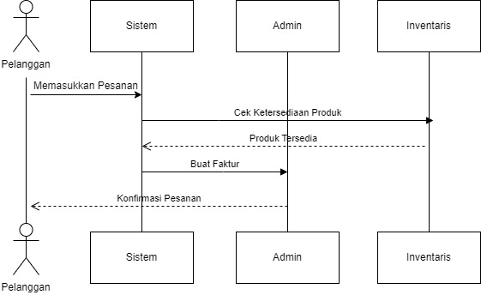(Draw.io)

1. Use Case Diagram

(Mermaid)

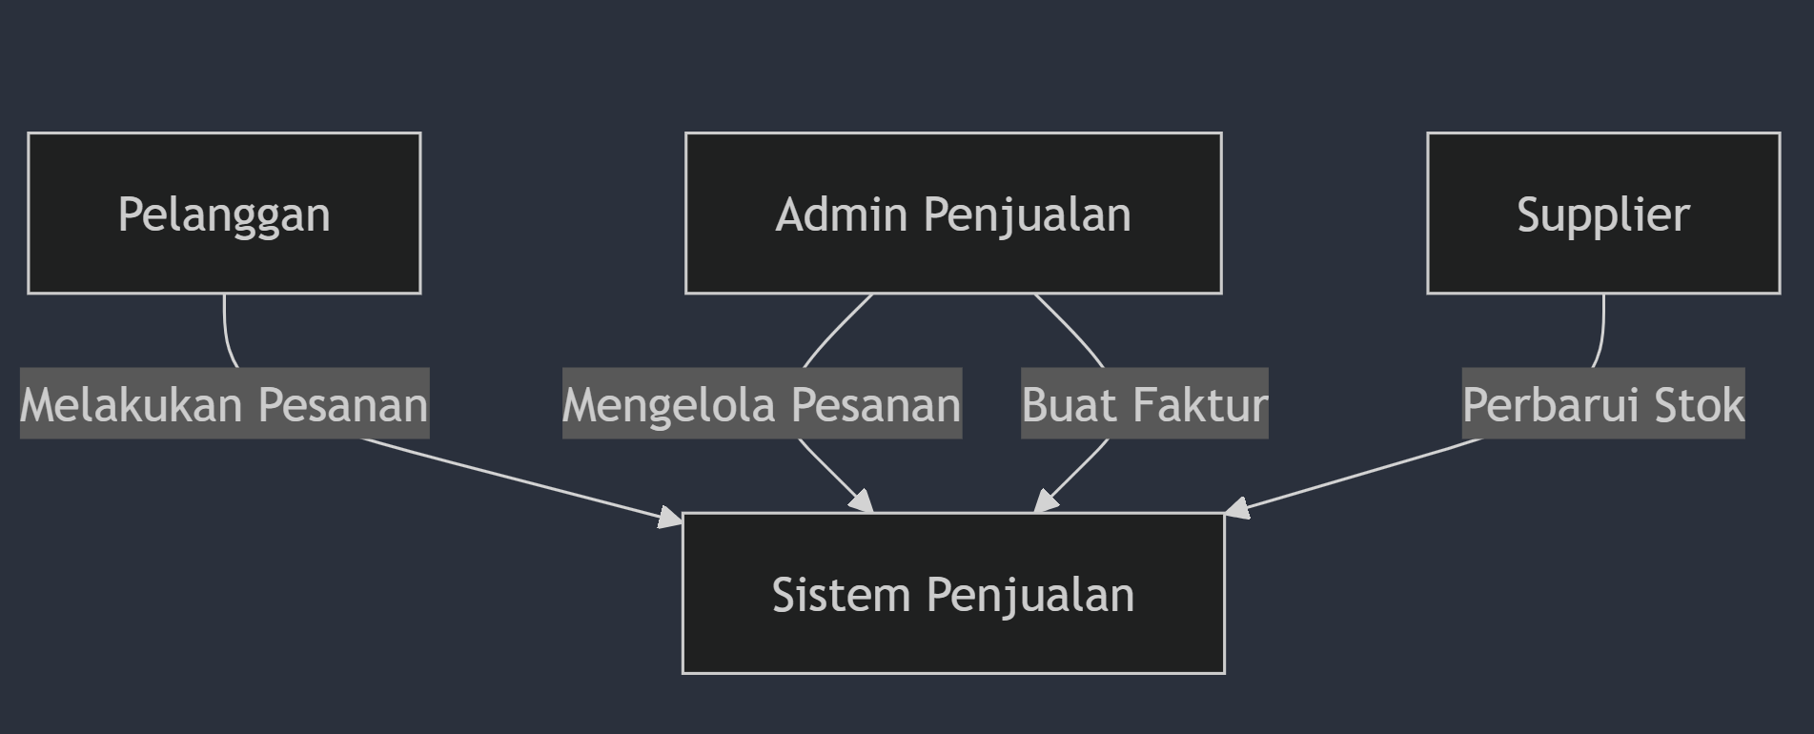

(Draw.io)

